|  |  |
| --- | --- |
| Name | : Fance Satria Nusantara |
| Class | : PPTI 21 |
| NIM | : 2802538611 |

When designing the user interface and prototype, I used a variety of visual elements such as images, icons, and fonts to help create a clearer, more consistent, and engaging user experience. This document lists all the image and font resources I used, along with their sources and licenses. I included this to ensure proper credit is given and to support transparency as well as any future improvements to the design.

* **Figma elements:**

These elements were created in Canva using graphic assets available within the Canva platform. All images and illustrations used are sourced directly from Canva’s built-in library of design elements.

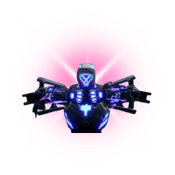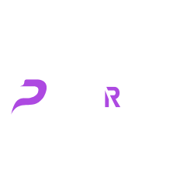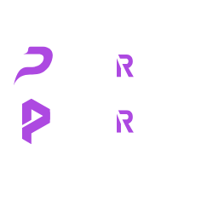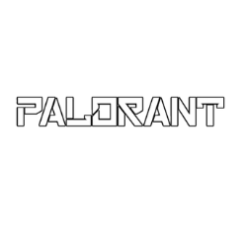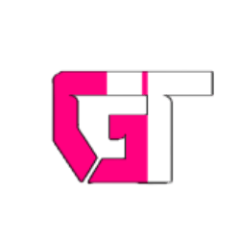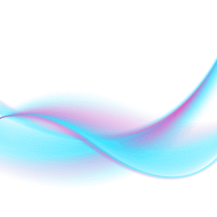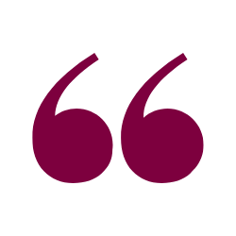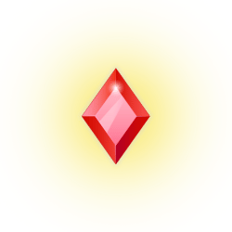

* **Banner Figma:**

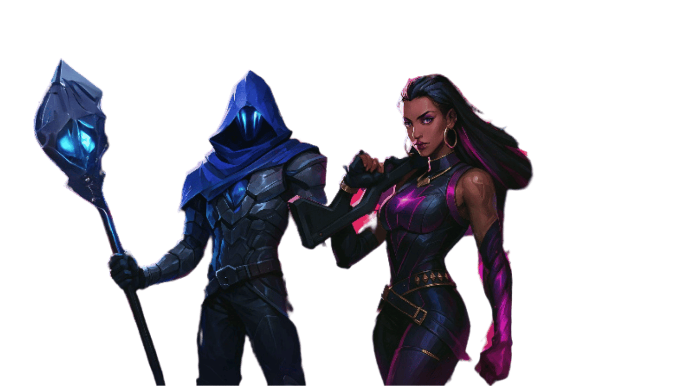

The banner figure for Figma was generated using AI tools provided by OpenAI. However, the references used to guide the AI generation were taken from the following sources:  
<https://images.app.goo.gl/A4EadbvHYQaieudv8>  
<https://images.app.goo.gl/euWhCK5sZvXP6JZH9>

* **Top agent figma:**

The images used in the Top Agent section were sourced from the internet and later enhanced and then expanded using Canva’s AI tools  
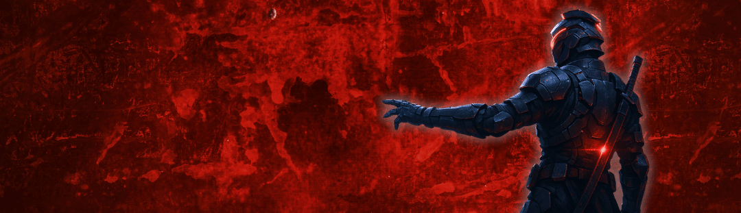

Exp: the background of one image was created or modified from Canva, while the character was generated using OpenAI’s DALL-E, based on the appearance of the Orion character (with reference images provided below in the Agent section).

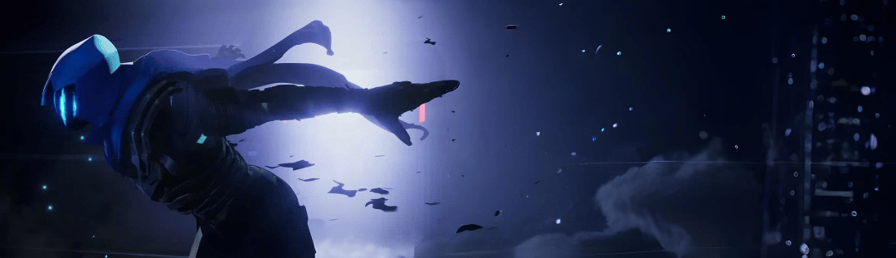

Src: <https://images.app.goo.gl/JEaaQ8BA2H9LLyv7A>

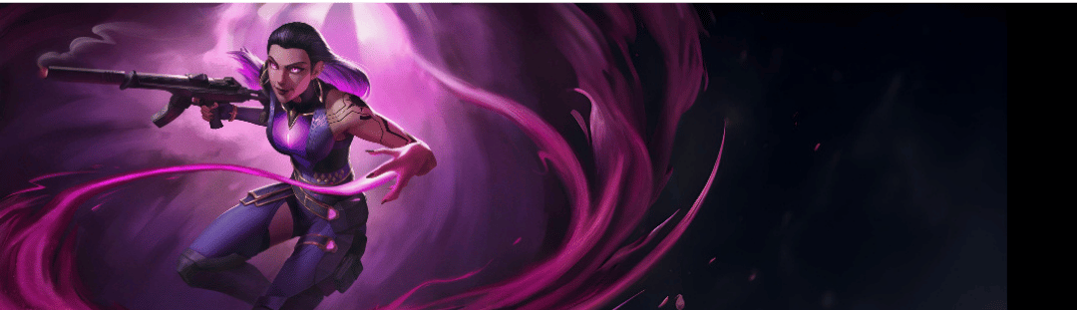

Src: <https://images.app.goo.gl/SfLzeLFckfj961JSA>

* **Figma backgrounds:**

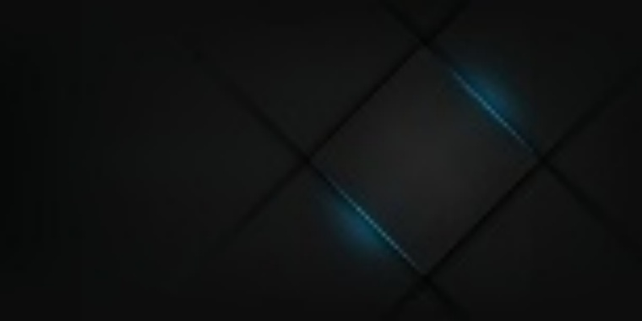

Get from internet, source: <https://images.app.goo.gl/Ekd3uWWUQasiDdHt8>

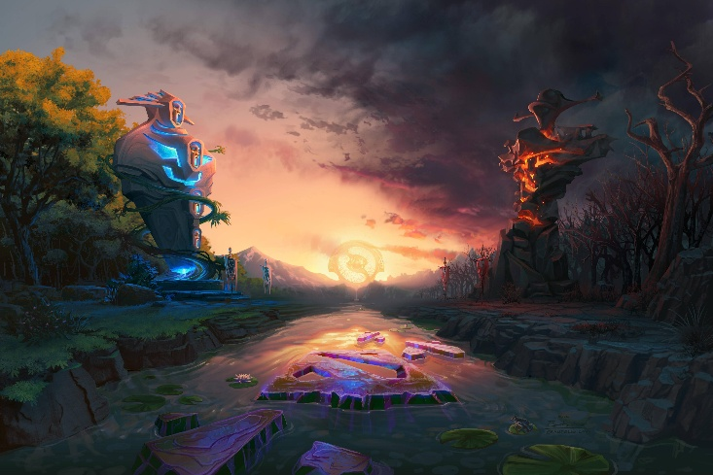

Get from internet, source: <https://images.app.goo.gl/GMfyWQGZoy9ULVvCA>

* **Website Agents:**  
  The Agent Card and Agent Detail Ability were originally created in Canva using various Canva elements and images sourced from the internet (references provided below). For the Figma version, I designed the layout directly in Figma, but for the website version, I recreated the design using Canva.  
  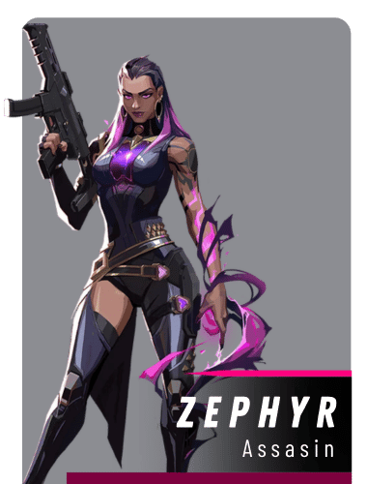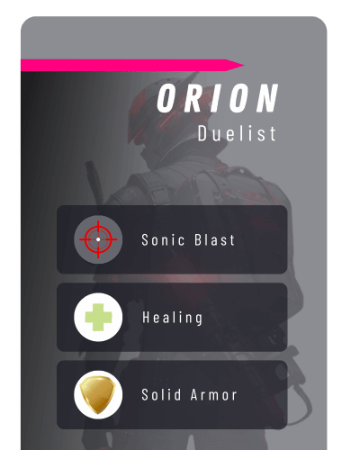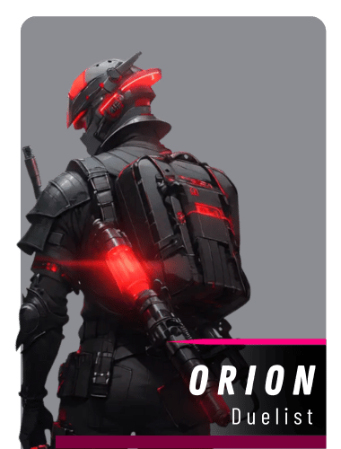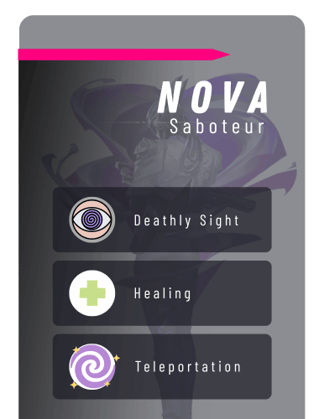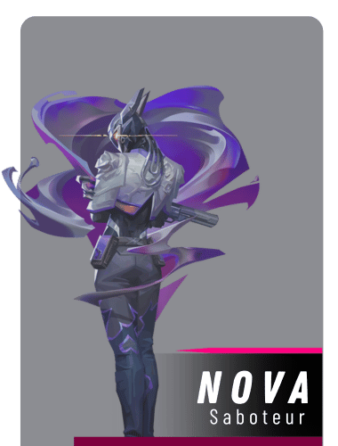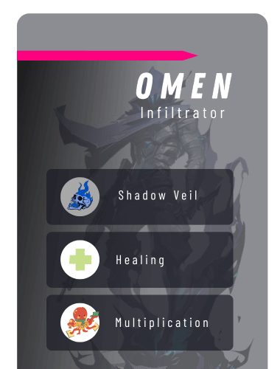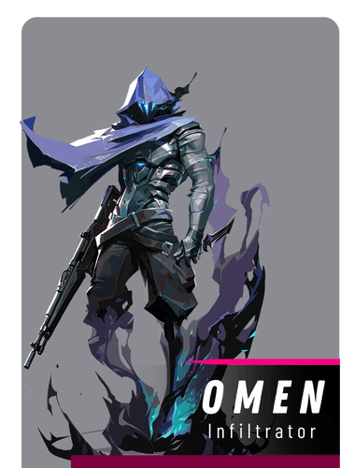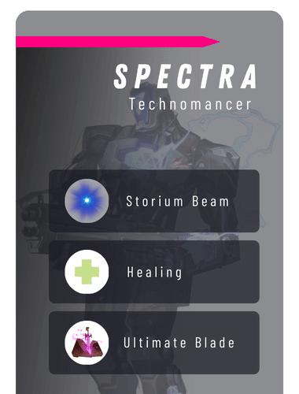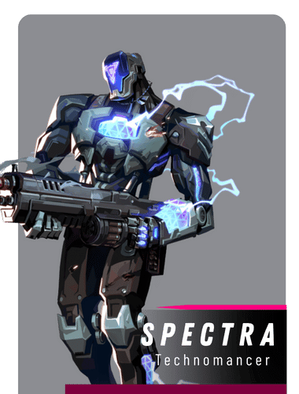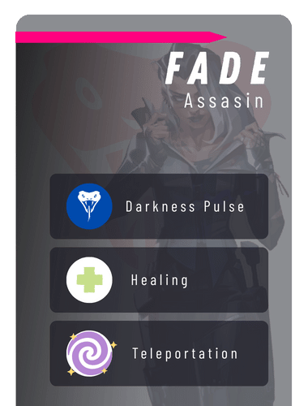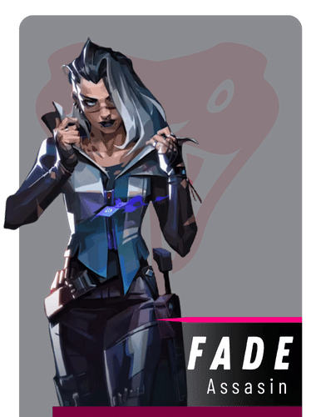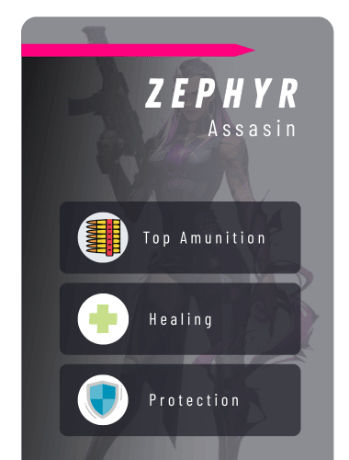
* **Maps:**

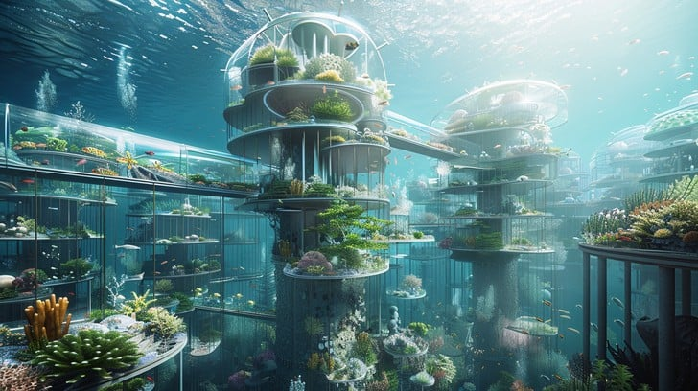

Get from internet, src: <https://images.app.goo.gl/erYMuERMEW5XAZ4Q9>

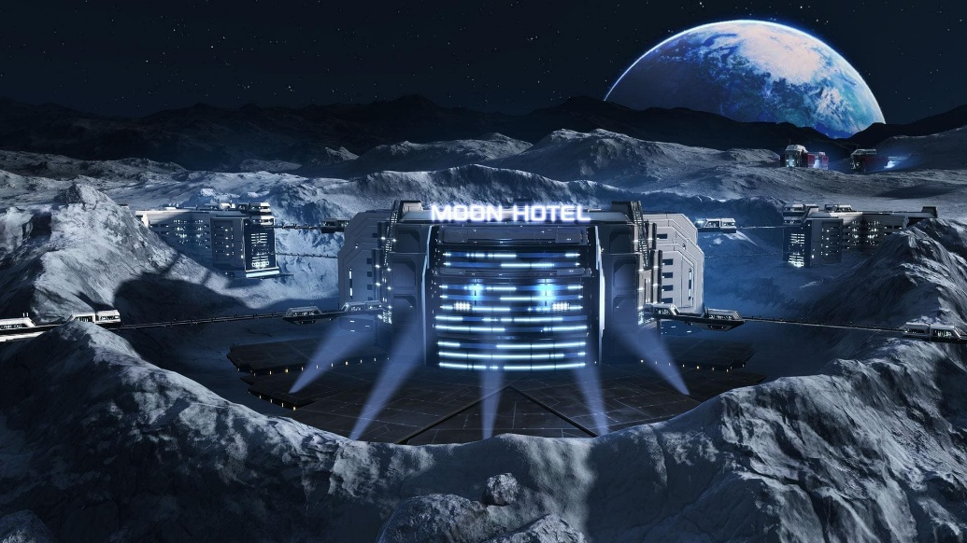

Get from internet, src: <https://images.app.goo.gl/bzhEFJwpQnTcvLZRA>

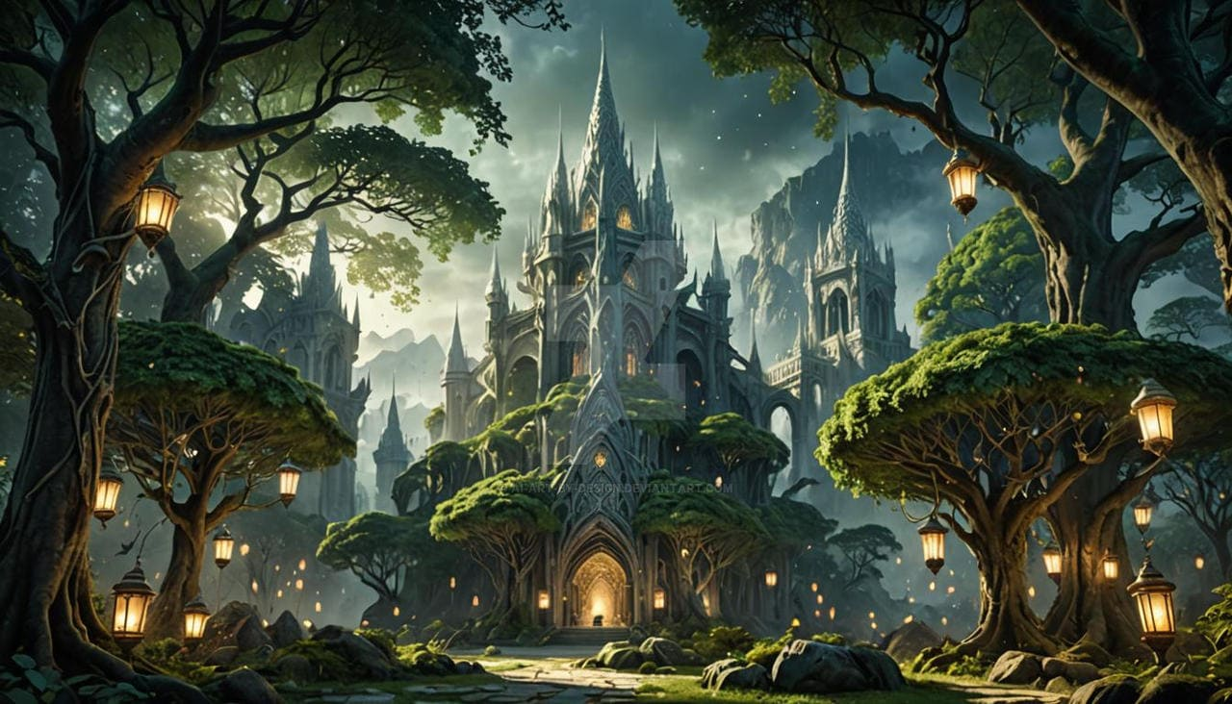

Get from internet, src: <https://images.app.goo.gl/1z6YNk8nopFVJVUv8>

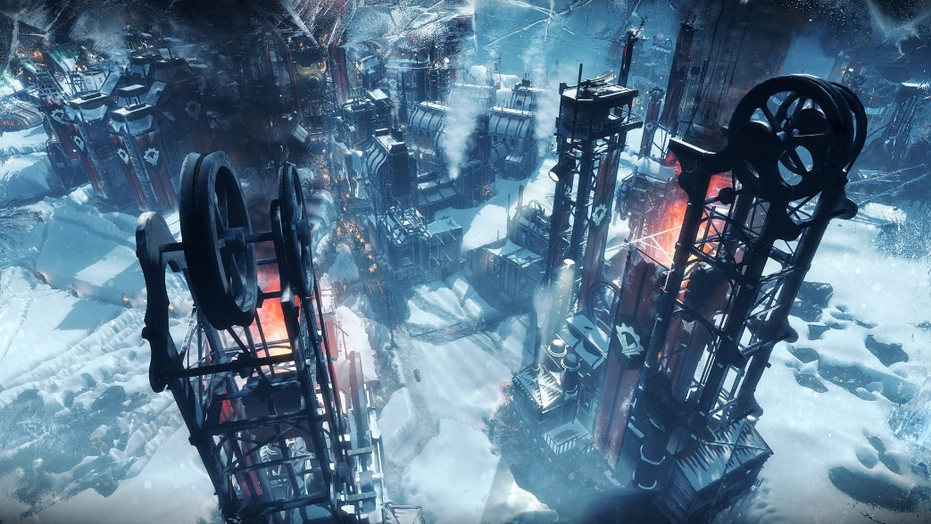

Get from internet, src: <https://images.app.goo.gl/zPv89EoSKJnfNpnS8>

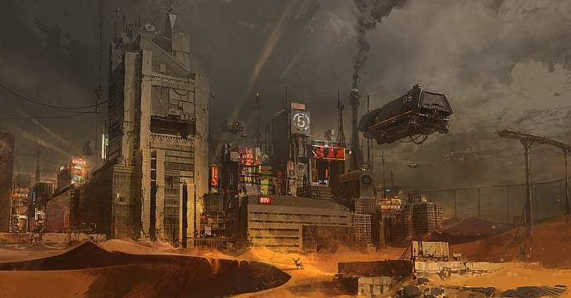

Get from internet, src: <https://images.app.goo.gl/Gpzd6pTPwmLCqyuM7>

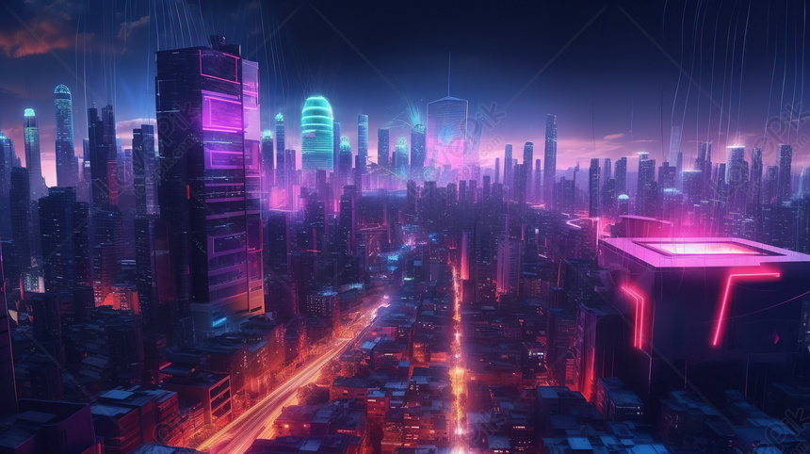

Get from internet, src: <https://images.app.goo.gl/EWm1Lbdrxm55tgbr9>

* **Agents:**

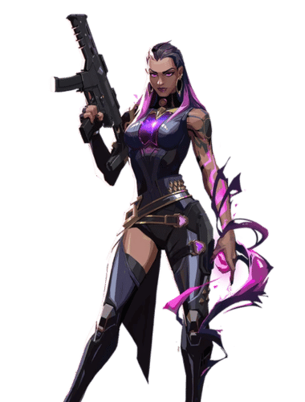

Get from internet, and then edited in canva for removing background, src: <https://images.app.goo.gl/XgcJMbt53kei2NAj8>

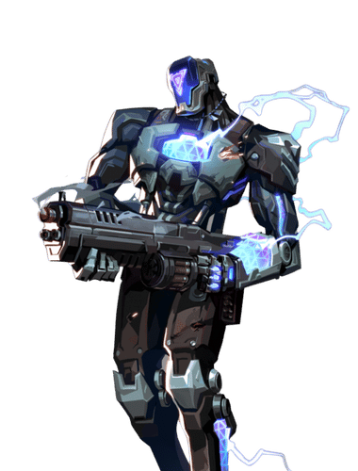

Get from internet, and then edited in canva for removing background, src: <https://images.app.goo.gl/ZtxoXRWpGCdoeoRe9>

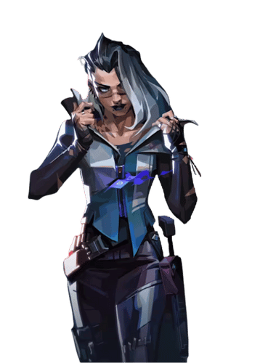

Get from internet, and then edited in canva for removing background, src: <https://images.app.goo.gl/u7yQTfNaf9BNibgs5>

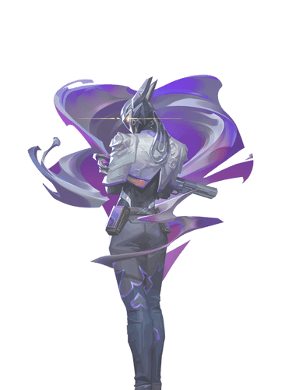

Get from internet, and then edited in canva for removing background, src: <https://images.app.goo.gl/fQRRiMBGhzz6xecc6>

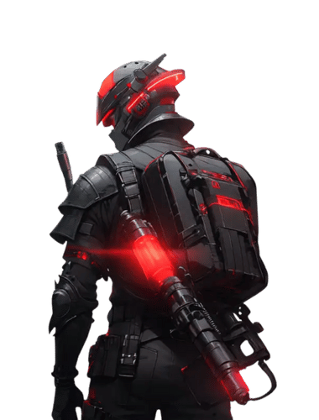

Get from internet, and then edited in canva for removing background, src: <https://images.app.goo.gl/w1VoxhfK24YpjrWp6>

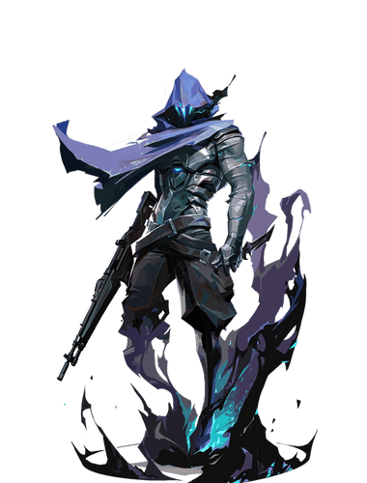

Get from internet, and then edited in canva for removing background, src: <https://images.app.goo.gl/1FR8TEmdVYByAg5v8>

* **News:**

For the news content (title, description)is generated from open ai

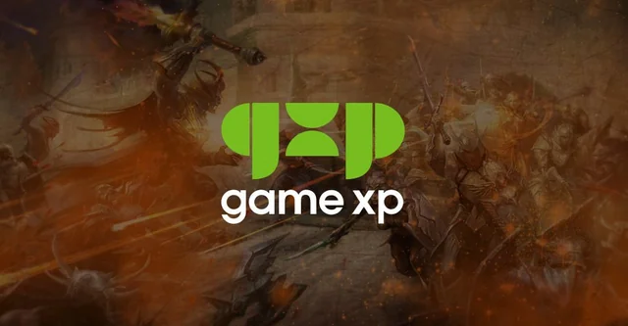

Src: <https://images.app.goo.gl/MHvEMFKtEdRh63Wx8>

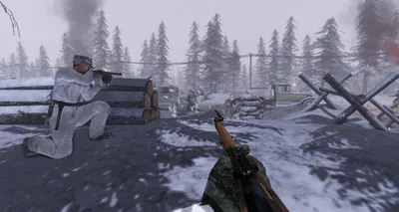

Src: <https://images.app.goo.gl/qFN6tGUMUwaC2ZgS8>

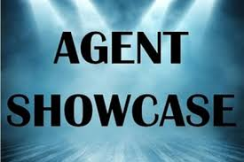

Src: <https://images.app.goo.gl/6q151sPei5N4BZWdA>

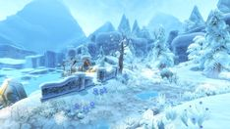

Src: <https://images.app.goo.gl/onm9FgaVDNnCfB1R6>

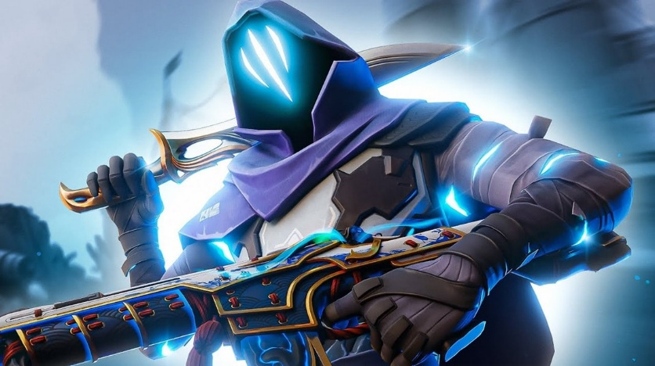

Src: <https://images.app.goo.gl/QJRMwXqwfZCiUKiv6>

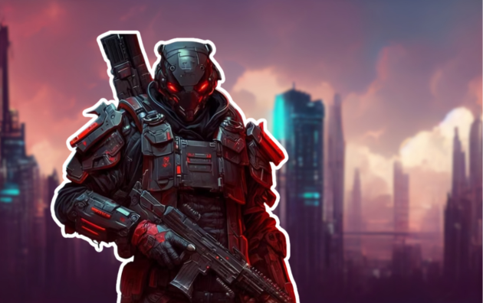

This image is created in canva, and the charcter or figure is get from <https://images.app.goo.gl/BeNmq9uMduVaWGfR6>

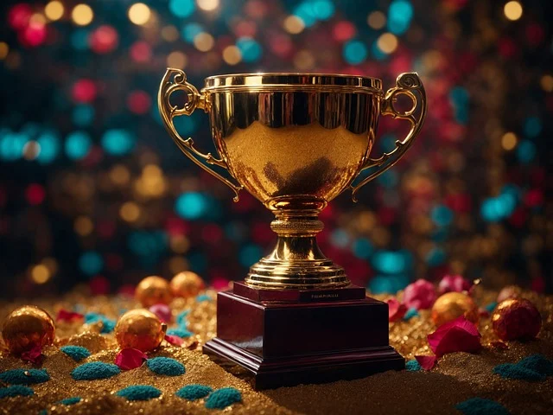

Src: <https://images.app.goo.gl/SbLwctFMtMjJJt1L6>

* **Website background:**



Src: <https://images.app.goo.gl/D2jvy2Xoc45DNwks6>

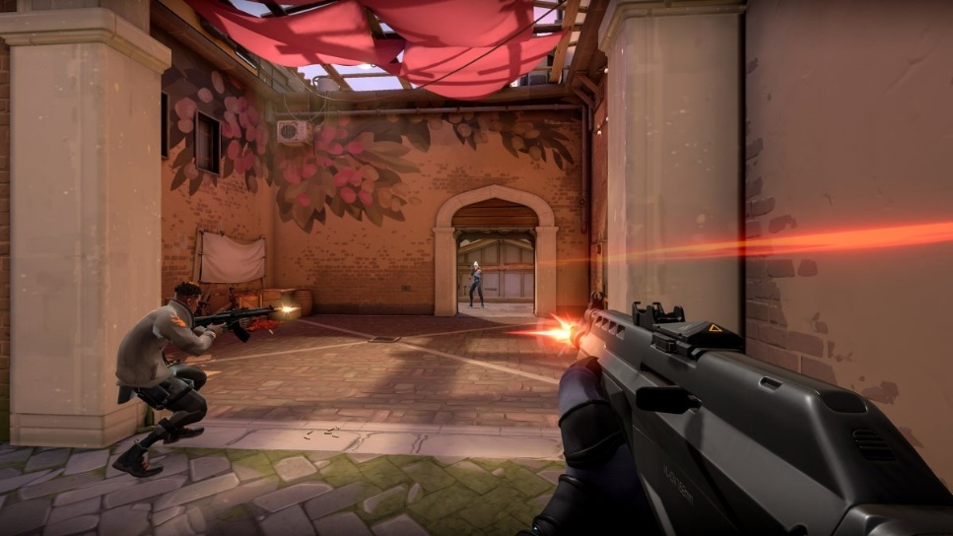

Src: <https://images.app.goo.gl/551eFt4TMTbPi2hY8>

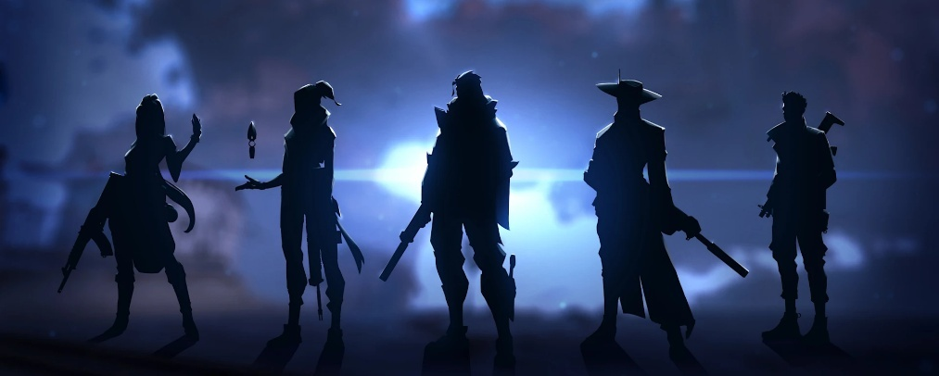

Src: <https://images.app.goo.gl/cyxERVEGaCFP113H6>



This dot pattern is created in canva using canva element

* **Video for web jumbotron:**

  
src: <https://youtu.be/I3edFNWoHwc?si=y7s1ifZ0-XCVqOjQ>

* **Fonts:**
* Game Battles font is downloaded from dafont, src: <https://www.dafont.com/game-battles.font>
* Overcame font is downloaded from 1001font, src: <https://www.1001fonts.com/overcame-demo-font.html>
* Groke Sport **(used in figma)** font is downloaded frm 1001font, src: <https://www.1001fonts.com/groke-sport-font.html>
* Omnitrinx **(used in figma)** font is downloaded from 1001font, src: <https://www.1001fonts.com/omnitrinx-font.html>